DML:
Insert Update Delete Select

- The MODIFY
There are three SQL commands to modify the database: INSERT, DELETE, and UPDATE

The INSERT Statement
Attribute values should be listed in the same order as the attributes were specified in Attributes with NULL values can be left out in the CREATE TABLE command
- Example: Insert a tuple for a new EMPLOYEE for whom we only know the FNAME, LNAME, and SSN attributes.
Ex . INSERT INTO EMPLOYEE (FNAME, LNAME, SSN)
VALUES ('Richard', 'Marini', '653298653')

Only the constraints specified in the DDL commands are automatically enforced by the DBMS when updates are applied to the database

The DELETE Statement

- Removes tuples from a relation
- Includes a WHERE-clause to select the tuples to be deleted
- Referential integrity should be enforced
- Tuples are deleted from only one table at a time (unless CASCADE is specified on a referential integrity constraint)
- A missing WHERE-clause specifies that all tuples in the relation are to be deleted; the table then becomes an empty table
Ex. : DELETE FROM EMPLOYEE
WHERE LNAME='Brown’
Ex. : DELETE FROM EMPLOYEE
WHERE SSN='123456789’
Ex. : DELETE FROM EMPLOYEE

The UPDATE Statement

- Used to modify attribute values of one or more selected tuples
- A WHERE-clause selects the tuples to be modified
- An additional SET-clause specifies the attributes to be modified and their new values
- Each command modifies tuples in the same relation
- Referential integrity should be enforced

UPDATE "table_name"
SET "column_1" = [new value]
WHERE {condition}
there is only one row that satisfies the condition in the WHERE clause. If there are multiple rows that satisfy the condition, all of them will be modified. If no WHERE clause is specified, all rows will be modified.

Syntax
UPDATE table_name
SET column1=value, column2=value2,...
WHERE some_column=some_value
Note : If we had omitted the WHERE clause. It will change all the records
It is also possible to UPDATE multiple columns at the same time.
UPDATE "table_name"
SET column_1 = [value1], column_2 = [value2]
WHERE {condition}
Ex.
DELETE FROM employee
WHERE ssn =
Ex. : UPDATE PROJECT SET PLOCATION = 'Bellaire', DNUM = 5
WHERE PNUMBER=10
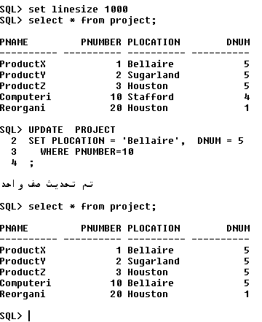

Operators Allowed in the WHERE Clause
With the WHERE clause, the following operators can be used:
Operator | Description
= | Equal
<> | Not equal
> | Greater than
< | Less than
>= | Greater than or equal
<= | Less than or equal
BETWEEN | Between an inclusive range
LIKE | Search for a pattern
IN | To specify multiple possible values for a column
Note: In some versions of SQL the <> operator may be written as !=

The SELECT Statement

- A query in SQL can consist of up to six clauses, but only the first two, SELECT and FROM, are mandatory. The clauses are specified in the following order:
SELECT <attribute list>
FROM <table list>
[WHERE <condition>]
[GROUP BY <grouping attribute(s)>]
[HAVING <group condition>]
[ORDER BY <attribute list>]

  - <attribute list> is a list of attribute names whose values are to be retrieved by the query
  - <table list> is a list of the relation names required to process the query
  - <condition> is a conditional (Boolean) expression that identifies the tuples to be retrieved by the query
In conditions you may use (= , < , > , <= , >= , <> , or , and , between , like )
- The SELECT-clause lists the attributes or functions to be retrieved
- The FROM-clause specifies all relations (or aliases) needed in the query but not those needed in nested queries
- The WHERE-clause specifies the conditions for selection and join of tuples from the relations specified in the FROM-clause
- GROUP BY specifies grouping attributes
- HAVING specifies a condition for selection of groups
- ORDER BY specifies an order for displaying the result of a query
- A query is evaluated by first applying the WHERE-clause, then GROUP BY and HAVING, and finally the SELECT-clause
Query 1: Select all attributes and all rows from employee
Answer: Select * from employee;
Query 2: Retrieve the SSN values for all employees.
Answer: SELECT SSN
FROM EMPLOYEE

Query 3: Retrieve the birthdate and address of the employee whose name is 'John B. Smith'.
Answer: SELECT BDATE, ADDRESS
FROM EMPLOYEE
WHERE FNAME='John' AND MINIT='B’ AND LNAME='Smith’
Query 4 : Retrieve the name and address of all employees who work for the 'Research' department.
Answer: SELECT FNAME, LNAME, ADDRESS
FROM EMPLOYEE, DEPARTMENT
WHERE DNAME='Research' AND DNUMBER=DNO
Query 5: For every project located in 'Stafford', list the project number, the controlling department number, and the department manager's last name, address, and birthdate.
Answer : SELECT PNUMBER, DNUM, LNAME, BDATE, ADDRESS
FROM PROJECT, DEPARTMENT, EMPLOYEE
WHERE DNUM=DNUMBER AND MGRSSN=SSN
AND PLOCATION='Stafford'
Query 6 : Retrieve the name and address of all employees who have salary between 200 and 400 .
Answer: SELECT FNAME, LNAME, ADDRESS
FROM EMPLOYEE
WHERE SALARY between 25000 and 40000 ;
aliases
Some queries need to refer to the same relation twice In this case, aliases are given to the relation name
Query 7: For each employee, retrieve the employee's name, and the name of his or her immediate supervisor.
Answer : SELECT E.FNAME, E.LNAME, S.FNAME, S.LNAME
FROM EMPLOYEE E S
WHERE E.SUPERSSN=S.SSN
Or: SELECT E.FNAME, E.LNAME, S.FNAME, S.LNAME
FROM EMPLOYEE AS E, EMPLOYEE AS S
WHERE E.SUPERSSN = S.SSN
Or: select E.FNAME , S.FNAME
FROM EMPLOYEE E,EMPLOYEE S
WHERE E.SSN=S.SUPER_SSN;

Query 8: SELECT SSN, DNAME
FROM EMPLOYEE, DEPARTMENT
**********gives false result we need to add condition ************ 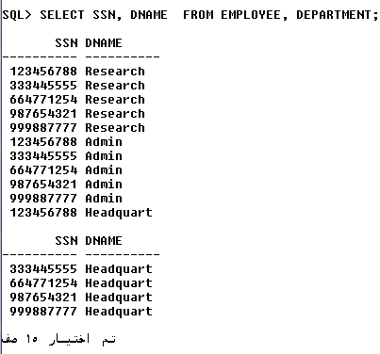

Query 9: Retrieve Fname, SSN values for all employees ordered by SSN in Ascending order (default )

select FNAME,SSN  from EMPLOYEE  order by SSN ; | select FNAME,SSN  from EMPLOYEE  order by SSN asc ;

Query 10: Retrieve Fname, SSN values for all employees ordered by SSN in descending order
select FNAME,SSN
from EMPLOYEE
order by SSN desc ;

sometimes we need to make update under condition
Query 11 : Give all employees in the 'Research' department a 10% raise in salary.
Answer : UPDATE EMPLOYEE
SET SALARY = SALARY *1.1
WHERE DNO IN (SELECT DNUMBER
FROM DEPARTMENT
WHERE DNAME='Research')
Query 12 : Give all employees in the 'Research' department a 10% raise in salary.
Answer : UPDATE EMPLOYEE
SET SALARY = SALARY *1.1
WHERE fname IN (SELECT fname
FROM employee WHERE fname='Jennifer');

Query 13 : Delete all employees in the 'Research' department

Answer : DELETE FROM EMPLOYEE
WHERE DNO IN (SELECT DNUMBER
FROM DEPARTMENT
WHERE DNAME='Research')

